How Do We Get Frequency Spectra from MR Signal?

The Power of the Fourier Transform

Table of Contents

*Expected Learning Outcomes* 3

Background Information 3

Classwide Discussion 4

Observation Experiments: Looking at FFTs of Sinusoidal Time-Domain Signals 4

Guided Inquiry Questions 5

Testing Experiment: Expanding Beyond Sinusoidal Functions 5

Guided Inquiry Questions 6

Observation Experiment: Exploring the FFTs of Periodic Time-Domain Signals 6

Guided Inquiry Questions 6

What Information Does the Fourier Transform Provide? 7

Using the Fourier Transform to Get Frequency Spectra from MR Time-Domain Signal 8

Guided Inquiry Questions 9

Reflection Questions 9

Cited Sources 10

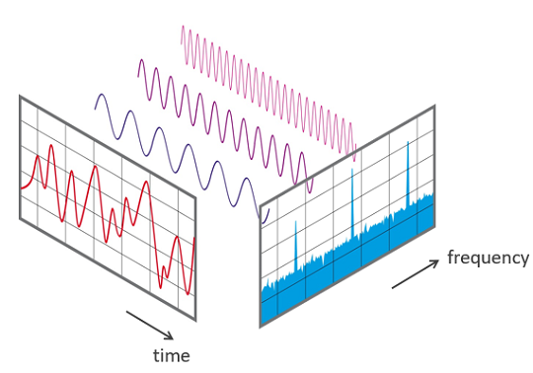

Image Source: Phonical, [CC BY-SA 4.0](https://creativecommons.org/licenses/by-sa/4.0), via Wikimedia Commons (1)

***Example Real-World Application*** The fast Fourier transform algorithm (FFT) - developed by James Cooley and John Tukey in 1965 - is considered one of the most important numerical algorithms in digital signal processing. This algorithm is at the root of many scientific analyses, medical imaging, as well as audiovisual compression schemes - check out [this video](https://www.youtube.com/watch?v=aqa6vyGSdos) for more information. Check out [this Veritasium video](https://www.youtube.com/watch?v=nmgFG7PUHfo) if you want to learn the fascinating origin story of the FFT algorithm and how it could have brought about the end of the nuclear arms race.



***Featured Mathematician*** Anne Gelb is an applied mathematician who develops computational methods based on foundational ideas from numerical approximation that can be used for a wide variety of applications, including MRI, ultrasound, speech recognition, and video surveillance. Read more about her work at <https://math.dartmouth.edu/~annegelb/>

Photo used with permission from Dr. Anne Gelb (2)

## *Expected Learning Outcomes*

*At the end of this module, students should be able to…*

1. *Identify what information the Fourier transform provides about a periodic signal (*[*Scientific Ability B7*](https://sites.google.com/site/scientificabilities/rubrics)*)*
2. *Use the provided equipment to acquire time-domain data and show the FFT (*[*Scientific Ability D3*](https://sites.google.com/site/scientificabilities/rubrics)*)*
3. *Sketch the frequency spectra that correspond to a simple sinusoidal time-domain signal in either graphical or in equation form (*[*Scientific Ability M7*](https://sites.google.com/site/scientificabilities/rubrics)*)*

**“Mathematical analysis … in the study of all phenomena, interprets them by the same language, as if to attest the unity and simplicity of the plan of the universe, and to make still more evident that unchangeable order which presides over all natural causes.”**

— Jean-Baptiste Joseph Fourier, *Théorie Analytique de la Chaleur* (1822), xv, translated by Alexander Freeman in *The Analytical Theory of Heat* (1878), 8.

# Background Information

**Fourier Transform** - the transformation of time-domain data into equivalent frequency-domain data, which we can write as *s(t)* FFT *S(f).*

In the previous module, we have seen that a lot of information about the sample can be gleaned from the time-domain MR signal, particularly information about the interactions of the spins with each other and with their environment. Our previous analysis was primarily looking at the *amplitude* of the MR signal and how it changes with time after performing certain pulse sequences. However, much of the relevant MR data is encoded in the *frequency* information. For example, the different precession frequencies present in the NMR signal can help us identify the chemical make-up and structure of the molecules in the sample, since it reveals the set of local magnetic fields sensed by the nuclear spins. Ideally, we would want an easy way to gather this frequency data, and the **Fourier transform** is the elegant tool that can give us this critical information.

In order to appreciate the power of the Fourier transform, you will need to review some features of sinusoidal functions. The time-dependent sinusoidal functions relevant for MR signal that we will be seeing will have the general form:

where is the amplitude of the sinusoidal function (with units of whatever variable we are measuring), is the frequency (units of Hertz = 1/seconds), and is a phase angle that effectively shifts the underlying sine function forward and backward in time.

**Jean-Baptiste Joseph Fourier** - a French mathematician and physicist best known for developing the field of harmonic analysis (or Fourier analysis) and its applications to heat transfer.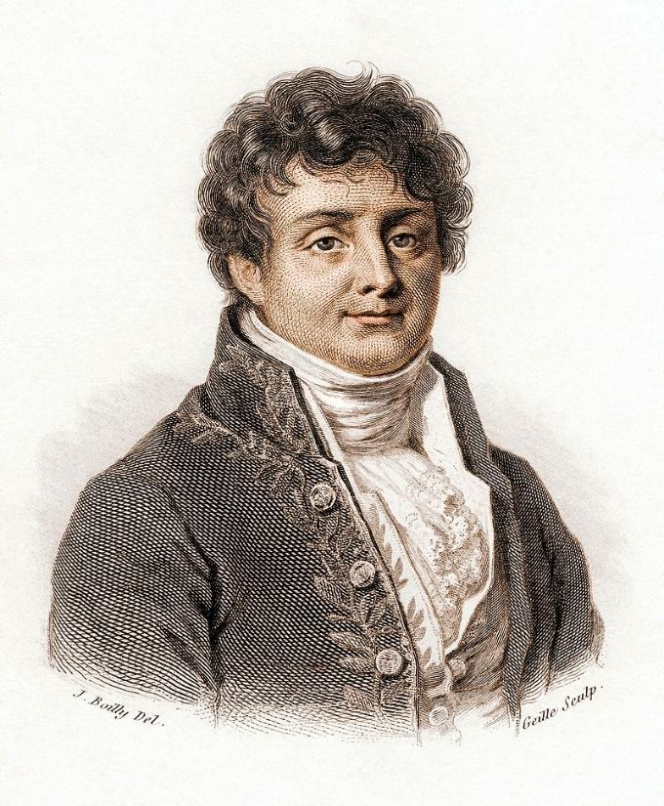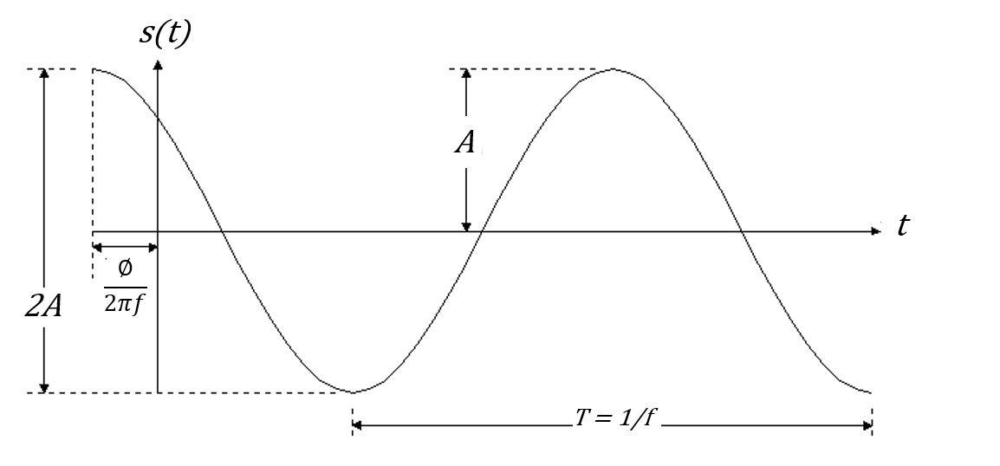

“Mathematics compares the most diverse phenomena and discovers the secret analogies that unite them.”  
- Joseph Fourier

Image source: Julien-Léopold Boilly, Public domain, via Wikimedia Commons (3)

## Classwide Discussion

* Where else have you seen sinusoidal functions?
* Why might sinusoidal functions be relevant for analyzing MR signal?

# Observation Experiments: Looking at FFTs of Sinusoidal Time-Domain Signals

To conduct these experiments, you will need:

1. a digital function generator OR [online tone generator](https://onlinetonegenerator.com/) that can create time-varying voltages with controllable frequency and amplitude
2. a digital oscilloscope OR [smartphone app](https://phyphox.org/) that can show that will show the Fourier transform of the time-domain signal calculated using the fast Fourier transform (FFT) algorithm

Set up your equipment and observe what happens as you go through the questions below.

## Guided Inquiry Questions

1. Have a lab partner set up any sinusoidal function they desire with the function generator and view it on the oscilloscope. Sketch the time-domain signal (i.e., the voltage versus time plot you see on the scope). Then have the scope show the FFT of this signal and sketch a new plot of what you see to the right of your time-domain plot.
2. Have a lab partner increase the frequency of the sinusoidal function. Below your previous sketches, sketch the time-domain signal and the resulting FFT.
3. Have a lab partner increase the amplitude of the sinusoidal function. Below your previous sketches, sketch the time-domain signal and the resulting FFT.
4. From your observations, what do you think the FFT is plotting (i.e., which parameters do the x- and y-axes seem to correspond to?)
5. Match up the three time-domain signals below with their corresponding FFTs.

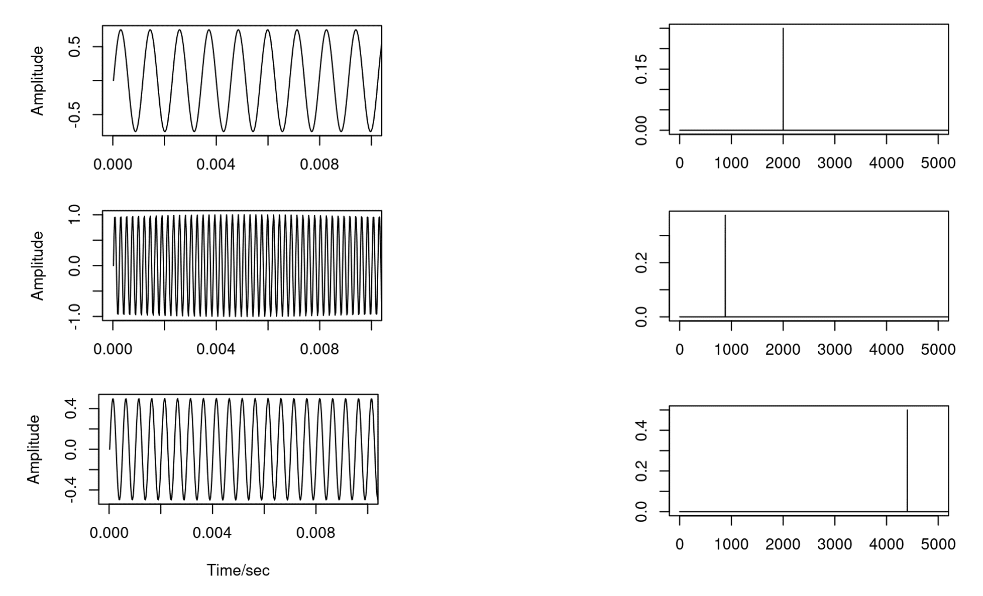

# Testing Experiment: Expanding Beyond Sinusoidal Functions

Let’s consider the following hypothesis:

The Fourier transform plots the amplitude versus the frequency of an inputted sinusoidal function.

## Guided Inquiry Questions

1. If the time-domain signal is the sinusoidal function given below, and the hypothesis above is true, sketch your prediction of the resulting FFT.
2. If the time-domain signal is instead a sum of two sinusoidal functions given below, sketch your prediction of the resulting FFT. *This case isn’t exactly covered in our hypothesis above, so you may need to give an expanded hypothesis to explain your prediction.*
3. Design and perform an experiment that can test the hypothesis given above. Write a brief summary of the experiment you performed, your results, and your conclusions regarding this hypothesis.

# Observation Experiment: Exploring the FFTs of Periodic Time-Domain Signals

Set up your digital function generator or tone generator to output a **periodic** but *non-sinusoidal* time-varying signal (e.g., a square or triangular waveform).

**periodic** - repeats itself in regular intervals or periods

## Guided Inquiry Questions

1. Sketch both the time-domain signal and the resulting FFT of your periodic but non-sinusoidal waveform.
2. What does the FFT of this periodic waveform suggest about how these periodic functions may be related to sinusoidal functions?

To further explore the relationship between periodic functions and sinusoidal functions, we will use the following Desmos calculator: <https://www.desmos.com/calculator/gjpuxeuwbj>. There are two variables ( and ) that you can set by clicking on the sliders below.

1. Observe what happens when you increase . What do you think is controlling?
2. What is happening to the frequency and amplitude of each of the blue sinusoidal functions that get added as you increase ?
3. Observe what happens when you increase . What do you think is controlling?
4. The red trace is the sum of all the sinusoidal blue traces shown. How can you adjust the settings to make the red trace better approximate a square wave?
5. Based on your answer above, sketch your prediction of the FFT of a square wave.
6. Alice and Sayed have come up with the following hypothesis regarding periodic functions:

All periodic functions can be written as an infinite sum of sinusoidal functions with different frequencies and amplitudes, such as

Is this hypothesis supported or disproved by what you have observed experimentally and learned from the Desmos calculator for the square wave?

# What Information Does the Fourier Transform Provide?

From your experiments above, you hopefully can see how Fourier transforms are an extremely useful tool that essentially allows you to pick out the various sine waves (characterized by particular frequencies and amplitudes) that are present in *any* periodic signal.



Image Source: Phonical, [CC BY-SA 4.0](https://creativecommons.org/licenses/by-sa/4.0), via Wikimedia Commons (1)

Doing a Fourier transform on a time-domain signal provides you with the frequency spectrum of the signal, where the size of the peaks denotes how much of the signal is at that particular frequency. The Fourier transform essentially presents the same information that is encoded in the signal in a different way, and often a far more condensed and useful way! For a more detailed interactive introduction to the Fourier transform, including its use in image compression algorithms, check out this website, [“An Interactive Introduction to Fourier Transforms by Jez Swanson”](https://www.jezzamon.com/fourier/index.html).

For MR data, the Fourier transform enables us to get the frequency information we really desire from our complicated-looking time-domain signal.

## Using the Fourier Transform to Get Frequency Spectra from MR Time-Domain Signal

As we learned from previous modules, the MR signal is usually a combination of a sinusoidal, time-varying signal, combined with some sort of exponential decay. In the figure below, you can see what the resulting Fourier transform looks like for two different simulated MR time-domain signals. Through the questions below, we’ll see how the information encoded in the time-domain signal shows up in the frequency spectra.

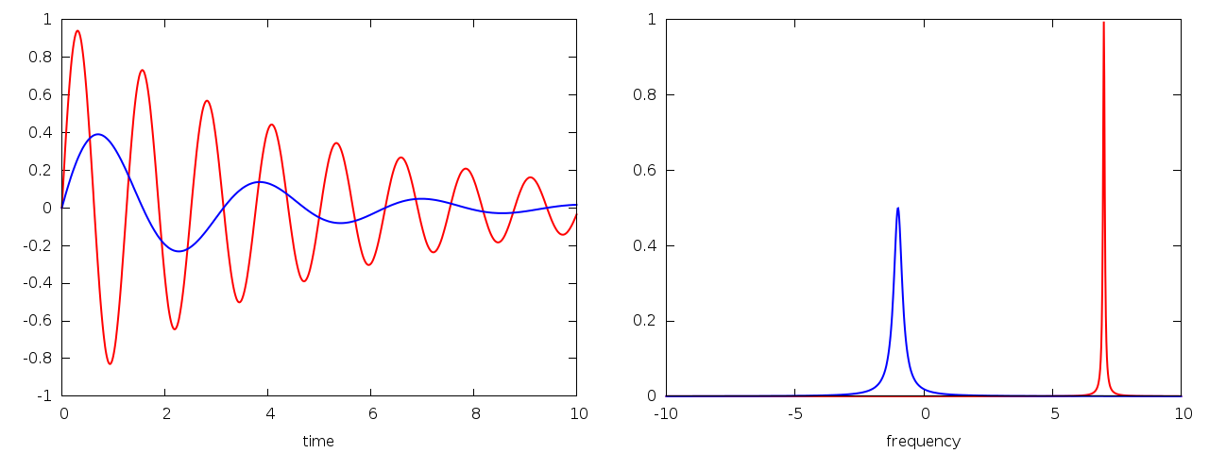

Image used with permission from Dr. Brendan M. Duggan (4)

For the signals above, you can assume the maximum amplitude of both signals in the time domain is 1, and the blue signal has a lower frequency and shorter time constant. The maximum amplitude in the time domain signal is related to the *area under the peak* in the frequency spectrum. A wider or broader peak in the frequency spectrum means that there is a wider range of frequencies being observed, which often indicates nuclei sensing slightly different local magnetic environments in addition to the large homogeneous magnetic field being applied.

The standard NMR spectrum you will see in NMR spectroscopy uses chemical shift measured in parts per million (ppm) along the x-axis. The figure below gives you a detailed primer to help you understand what you are seeing in a standard NMR spectrum. (Check out our [chemistry modules](https://sites.google.com/view/makingnmr/chemistry-modules) to learn how to analyze NMR spectra to determine the molecular structure of the sample!)

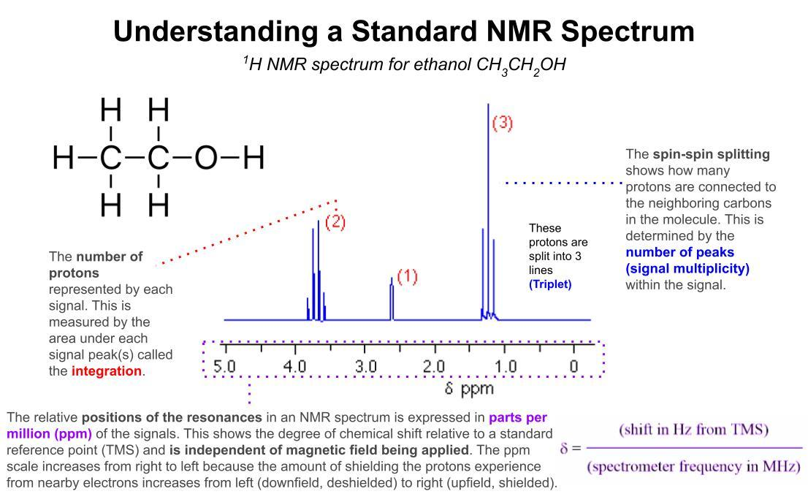

## Guided Inquiry Questions

1. How does the exponential decay of a sinusoidal time-domain signal appear to impact the height and width of the Fourier transform peak?
2. As the signal decays faster (i.e., shorter relaxation time), does the width of the peak in the frequency spectrum decrease or increase? Does this match with the following description of the cause of * relaxation - the spins in the sample are seeing different magnetic field environments and thus have slightly different precession frequencies that cause them to dephase. Explain your reasoning.

# Reflection Questions

1. Where else might being able to gather frequency information from time-domain signals be useful? *You can watch* [*this video*](https://www.youtube.com/watch?v=aqa6vyGSdos)*, which was cited in the Example Real-World Application above, to get some ideas*.
2. Why might MR scientists primarily look at frequency spectra instead of the directly acquired time-domain data?

The following questions make use of the figure below.

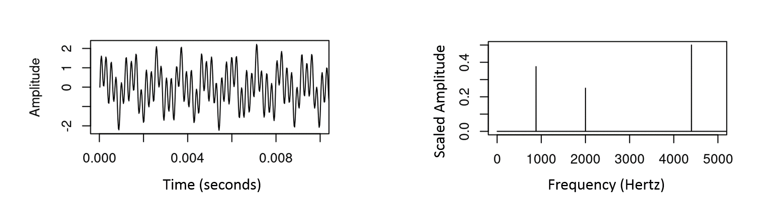

1. What approximate frequencies are present in the periodic signal shown in the figure above?
2. Do all the frequencies contribute equally to the signal? Why or why not?
3. Write a possible mathematical equation for the time-domain signal, assuming it is a sum of multiple sinusoidal functions. Please use a form similar to the many given in the text.

## Cited Sources

1. <https://commons.wikimedia.org/wiki/File:FFT-Time-Frequency-View.png>“Wikimedia Commons File:FFT-Time-Frequency-View.png”
2. <https://math.dartmouth.edu/~annegelb/> “Homepage for Anne Gelb”
3. <https://commons.wikimedia.org/wiki/File:Fourier2_-_restoration1.jpg> “Engraved portrait of French mathematician Jean Baptiste Joseph Fourier”
4. <http://sopnmr.blogspot.com/2015/11/processing-fourier-transform.html> “Processing: the Fourier Transform”